**Java Coding**

1. Print the result of the below Java code? You can add libraries or any extra line to get the result.

public class CodingTest {

public static void main(String[] args) {

ArrayList<String> list = new ArrayList<String>();

for (int i = 0; i < 10; i++) {

list.add(String.valueOf(i));

}

for (int i = 0; i < 5; i++) {

list.add(String.valueOf(i));

}

System.out.println("Input list : " + list);

System.out.println("\nfound result : " + processList(list));

}

public static Set<String> processList(List<String> identifyResults) {

final Set<String> resultSet = new HashSet<String>();

final Set<String> tempSet = new HashSet<String>();

for (String yourInt : identifyResults) {

if (!tempSet.add(yourInt)) {

resultSet.add(yourInt);

}

}

return resultSet;

}

}

**Result of above Java code will be :**

[0, 1, 2, 3, 4]

1. Write a Java code to print the next number of 22, 19, 15, 10, __?__

**Java code:**

package acoustic;

import java.util.ArrayList;

import java.util.List;

public class Test {

public static void main(String[] args) {

int num = 22;

List<Integer> list = new ArrayList<Integer>();

list.add(num);

for (int i = 3; i < 10; i++) {

num -= i;

if(num<0) {

break;

}

list.add(num);

}

System.out.println(list);

}

}

**Output** : [22, 19, 15, 10, 4]

1. Write a Java code to calculate a profit percentage if an Item cost is INR 80 and the selling price is INR 120. Print the result.

**Java code:**

package acoustic;

import java.util.Scanner;

public class Test {

public static void main(String[] args) {

float itemCost, sellingPrice, profit, percentProfit, loss, percentLoss;

//float itemCost = 80;

//float sellingPrice = 120;

Scanner sc = new Scanner(System.in);

System.out.println("Enter the item cost");

itemCost = sc.nextFloat();

System.out.println("Enter the selling price");

sellingPrice = sc.nextFloat();

if (sellingPrice > itemCost) {

System.out.print("Congratulations!!! you earned profit on this item and ");

profit = sellingPrice - itemCost;

percentProfit = (profit / itemCost) * 100;

System.out.println("Profit percentage is " + (int) percentProfit + "%");

} else if (sellingPrice < itemCost) {

System.out.print("Oops. You are in loss after selling this item and ");

loss = sellingPrice - itemCost;

percentLoss = Math.abs((loss / itemCost) * 100);

System.out.println("Loss percentage is " + (int) percentLoss + "%");

} else {

System.out.println("No Profit, No Loss");

}

}

}

**SQL Questions:**

1. Write a SQL query to get the below data for all the employees

|  |  |  |  |
| --- | --- | --- | --- |
| EmployeeID | Designation | FixedPay | VariablePay |

Table name: EMPLOYEE

|  |  |  |  |  |
| --- | --- | --- | --- | --- |
| EmployeeID | FirstName | LastName | JoiningDate | FixedPay |
| 1 | Kamal | Dubey | 2018-02-20 | 66666 |
| 2 | Kamala | Chopra | 2016-03-20 | 60000 |
| 3 | Vikas | Mane | 2017-04-20 | 70000 |
| 4 | Anant | Chawla | 2019-05-20 | 50000 |
| 5 | Vikas | Hegde | 2019-05-20 | 60000 |

Table Name: BONUS

|  |  |  |  |
| --- | --- | --- | --- |
| EmployeeID | Rating | VariablePay | Designation |
| 1 | 1 | 5555 | Developer |
| 2 | 1 | 5550 | Tester |
| 3 | 2 | 2345 | Developer |
| 4 | 3 | 1234 | Tester |
| 5 | 1 | 6000 | Developer |

**Query :**

SELECT e.EmployeeID, b.Designation, e.FixedPay, b.VariablePay

FROM EMPLOYEE e, BONUS b

WHERE e.EmployeeID = b.EmployeeID;

**OR**

SELECT EMPLOYEE.EmployeeID, BONUS.Designation, EMPLOYEE.FixedPay, BONUS.VariablePay

FROM EMPLOYEE INNER JOIN BONUS ON EMPLOYEE.EmployeeID = BONUS.EmployeeID;

1. Write an insert query to insert a new employee data in the EMPLOYEE table as below

|  |  |  |  |  |
| --- | --- | --- | --- | --- |
| 6 | Mandeep | Singh | 2020-05-20 | 40000 |

**Query:** INSERT INTO EMPLOYEE VALUES (6,’Mandeep’, ‘Singh’, ‘2020-05-20’, 4000);

1. Delete the record of EmployeeID 3 from EMPLOYEE table

**Query:** DELETE from EMPLOYEE where EmployeeID=3;

1. Write a query to get only Developer

**Query:** SELECT * from EMPLOYEE

WHERE EmployeeID IN

(SELECT EmployeeID FROM BONUS

WHERE Designation = ‘Developer’);

1. Write a query to get only unique FirstName from EMPLOYEE table

**Query:** SELECT DISTINCT FirstName FROM EMPLOYEE;

1. Write a query to get employees whose variable pay is between 2000 and 3000

**Query :** SELECT * from EMPLOYEE

WHERE EmployeeID in

(Select EmployeeID from BONUS

WHERE VariablePay BETWEEN 2000 AND 3000;

1. Write a query to get employees who joined before 2019

**Query:** SELECT * FROM EMPLOYEE

WHERE JoiningDate < ’2019-01-01’;

**Test Automation:**

Write the Test cases for the below and automate them using Selenium webdriver.

Please automate the below page using any browser. URL: [www.tourismtest.com](http://www.tourismtest.com)

Page1:

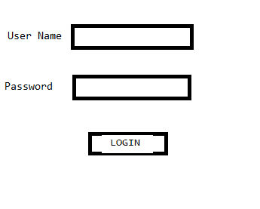

Once logged in successfully, it navigates to next page as below.

Page2:

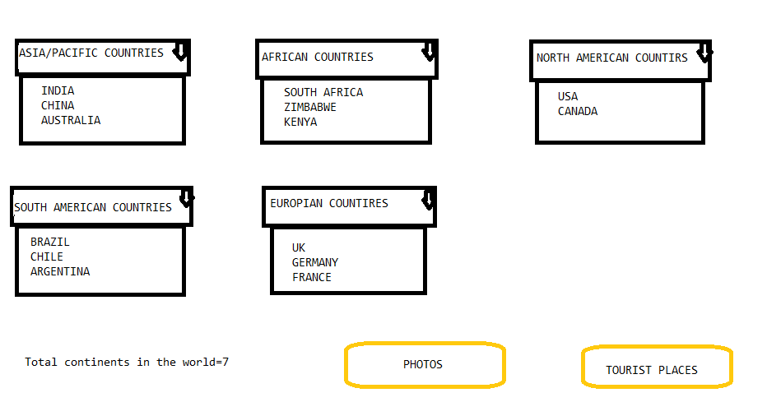

There are dropdowns in the page2 as above. Example:When clicked on ASIA/PACIFIC OUNTIRES it shows all the countries of Asia/Pacific in the dropdown. Similarly, other dropdown shows the respective countries in that dropdown. If INDIA is selected from the ASIA/PACIFIC OUNTIRES dropdown and clicked on the button “PHOTOS” then in the next page photos related to INDIA will be displayed, similarly if INDIA is selected and clicked on the button “TOURIST PLACES” then the tourist places of INDIA will be displayed in the next page shows.

You do not need to automate the next pages where photos and tourist places are displayed. You can automate up to the above page2.

**-> Test Cases and automation code is uploaded to below github repository:**

**https://github.com/RavindraPatil1292/Acoustic.git**